***Smart Pick and Place Robot for Hospital Waste Management***

**Abstract**

Robotics automation has revolutionized a number of industries by increasing productivity, simplifying jobs, and lowering the need for human intervention in dangerous or labour-intensive procedures. Effective waste segregation is essential for preserving hygienic conditions and lowering the danger of biohazards in healthcare settings. In order to separate old cotton and syringes, this project presents a sophisticated Pick and Place Robot specifically made for medical waste management. For real-time object recognition and classification, the system makes use of YOLOv8, a sophisticated deep learning model that is built on a Raspberry Pi. An Arduino-controlled robotic arm classifies and sorts the recognized objects into bins, one for cotton and another for syringes. Smooth functioning in dynamic situations is ensured by ultrasonic sensors, which provide accurate obstacle detection and navigation. By combining these technologies, the chance of human error is reduced and dependable performance is guaranteed. This robot has many advantages over current manual or semi-automated techniques. Its autonomous functioning lessens dependency on physical labour and exposure to biohazardous materials, while its use of cutting-edge image processing guarantees excellent accuracy in object identification. The system is a workable and secure solution for healthcare settings because of its effectiveness, scalability, and continuous operation. This study demonstrates the potential of intelligent automation in tackling healthcare issues by fusing robots and artificial intelligence. In addition to improving waste management procedures, the robot establishes the groundwork for more extensive hospital automation applications, which will make the healthcare system safer, cleaner, and more effective.

**Index Terms:**Robotics, Automation, YOLOv8, Raspberry Pi, Arduino, Ultrasonic Sensors, Medical Waste Management, Deep Learning, Object Detection, Healthcare Automation

**Introduction**

With its capacity to automate processes, boost productivity, and reduce the need for human interaction, robotics has become a game-changing technology that is transforming a variety of industries. Robotic automation has enormous promise in the healthcare industry, especially in hospitals, to handle important issues including operating efficiency, waste management, and hygiene maintenance. To maintain safety and avoid contamination, hospital waste—including biohazardous materials like cotton and syringes—needs to be handled and separated precisely. Because processing such garbage by hand puts healthcare personnel at serious risk, better and more effective solutions must be developed.

The design and deployment of a Pick and Place Robot to automate hospital waste sorting is the main goal of this project. The robot is outfitted with cutting-edge technologies, such as an Arduino-based control system for accurate actuation, a Raspberry Pi for processing, and a YOLOv8 for object identification and categorization. By utilizing these parts, the robot ensures appropriate segregation without the need for human intervention by recognizing items such as cotton and syringes, picking them up with a robotic arm, and placing them in appropriate bins.

High precision and dependability are guaranteed by the combination of state-of-the-art image processing methods with effective hardware elements. Real-time processing capabilities are provided by the cutting-edge object detection model YOLOv8, and computing efficiency in a small form factor is offered by the Raspberry Pi. The robot can move on its own in dynamic medical surroundings thanks to the use of ultrasonic sensors, which enable obstacle detection. This robotic approach guarantees constant and accurate waste treatment, lowers labor costs and removes direct human exposure to biohazardous materials. Beyond trash management, the system's scalable architecture allows it to be tailored to a range of healthcare applications.

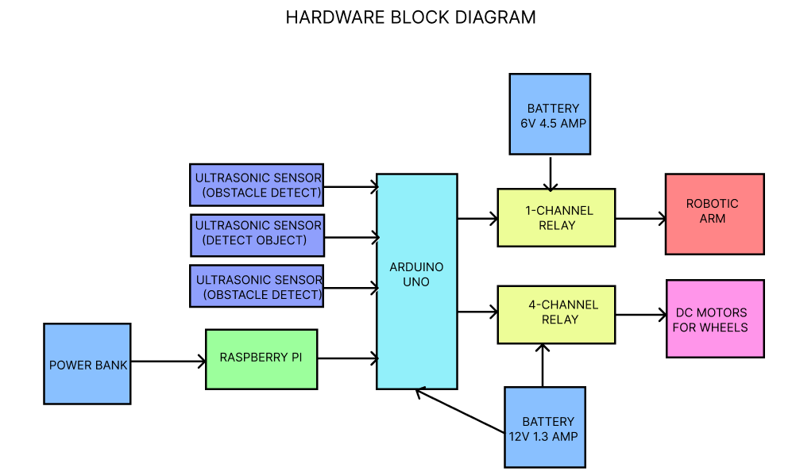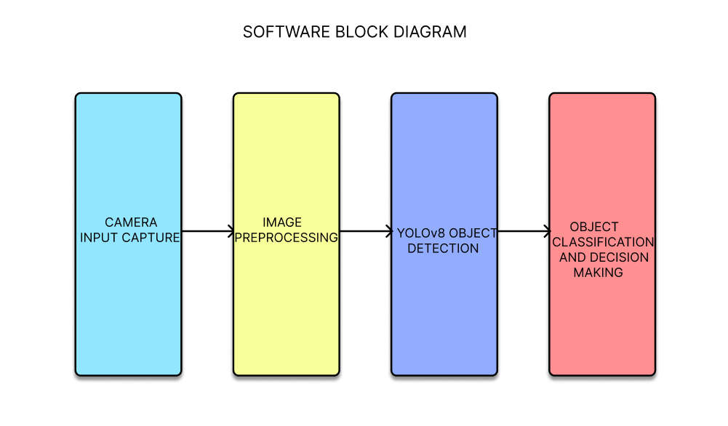

**Methodology**

In order to achieve effective waste segregation in medical settings, the Pick and Place Robot methodology combines complex hardware design with cutting-edge software capabilities. A Raspberry Pi 4 B+ (4GB RAM), an Arduino Uno, a USB camera, three ultrasonic sensors, a four-wheel base, a robotic arm, and two battery power sources are among the essential parts of the system. Together, these elements allow for garbage sorting, precise object detection, and autonomous movement.

The robot's central processing unit (CPU), the Raspberry Pi 4 B+, manages all picture processing and decision-making duties. The robot's USB camera records live photographs of the stuff it encounters. The Raspberry Pi receives these photos and uses the YOLOv8 object detection model to process and classify the data. The state-of-the-art deep learning model YOLOv8 is perfect for real-time applications like robotic automation since it can recognize objects quickly and accurately. The model recognizes and categorizes the objects it sees, having been particularly trained on a dataset of hospital waste products such as syringes and cotton. The way YOLOv8 works is by creating a grid out of the input image, where each cell predicts the bounding boxes and class probabilities for possible items. Even in dynamic contexts, the model's excellent accuracy and speed provide dependable real-time performance.

Following item detection and classification, YOLOv8 transmits the findings to the Raspberry Pi's control system. The system then uses a communication channel like UART or USB to provide the categorization data—such as cotton or syringe—to the Arduino Uno. Receiving commands and carrying out the required physical activities, the Arduino Uno serves as the interface between the hardware components and the software system.

The robotic arm, which has four G90 servo motors to carry out the pick-and-place function, is controlled by an Arduino Uno. The arm can pick up the recognized object and put it in the proper bin because the servo motors accurately control its movement. The Raspberry Pi's classification results serve as the basis for the arm's movements. The Arduino Uno sends signals to the servo motors through a 5V relay, which controls the power to the arm's motors to guarantee precise object handling.

The robot is outfitted with three HC-SR04 ultrasonic sensors for navigation and obstacle avoidance. These sensors are positioned strategically to identify impediments in the robot's route. In order to calculate the distance to surrounding objects, these sensors emit ultrasonic pulses and monitor the time it takes for the pulse to return. The robot will halt in order to prevent collision if it detects an obstruction within a predetermined range. This capability is essential for guaranteeing the safety of the robot, particularly in a busy hospital setting where there are numerous possible obstacles.

Two DC motors that drive the robot's wheels provide the power for its mobility. A 12V 1.3Ah battery powers a 12-volt, four-channel relay module that controls the motors. With their 75mm diameter and 45mm width, the wheels offer steady mobility on hospital floors. The relay makes sure that the right motor gets the right amount of power, and the motors are in charge of moving the robot to the object's location.

To maximize power efficiency, the robot's parts are also powered by two different batteries. The Arduino and the 4-channel relay are powered by the first battery, a 12V 1.3Ah, while the servo motors are powered by a second battery, a 6V 4.5Ah, through a bug converter board. Each component will have a steady power source thanks to this dual battery arrangement, allowing it to function independently without experiencing power surges.

Autonomous navigation, accurate object handling, and real-time object identification are made possible by YOLOv8's integration with the robot's hardware. Fast decision-making is ensured by the Raspberry Pi's powerful processing capacity and the YOLOv8's effective image processing skills, while the Arduino Uno dependable handles the robot's mechanical components. The robot's safety is improved by the ultrasonic sensors, which keep it from running into hospital obstacles.

This approach offers a complete solution for automating hospital waste management, especially when it comes to separating syringes and cotton into the appropriate bins. The exceptional efficiency of the robot, which is driven by YOLOv8 and dependable hardware, reduces human exposure to potentially hazardous biohazardous chemicals and guarantees dependable and safe operations in a medical setting. This system offers a scalable solution for healthcare waste management and increases operational efficiency by automating waste sorting.

**Hardware Requirements**

**Raspberry Pi 4 B+ (4GB RAM):**  
The Raspberry Pi 4 B+ acts as the central processor for image processing with YOLOv8. It handles real-time object detection and communicates with the Arduino for controlling the robot’s movements.

**USB Camera:**  
The USB camera captures real-time images of objects in the robot’s path. These images are then processed by YOLOv8 for object detection and classification.

**Arduino Uno:**  
The Arduino Uno interprets the processed data from the Raspberry Pi and controls the robotic arm and wheel motors. It ensures accurate execution of tasks based on received commands.

**4-Channel Relay (12V DC for DC Gear Motor):**The 4-channel relay controls the DC gear motors for the robot's movement. It allows the wheels to turn by switching power on and off, enabling the robot to move as directed by the Arduino.

**1-Channel Relay (5V for Servo Motors)**:  
The 1-channel relay controls the servo motors for the robotic arm. It activates the arm’s movement based on signals from the Arduino, enabling pick-and-place tasks.

**Battery 1 (12V, 1.3Ah)**:  
Battery 1 powers the Arduino and the 4-channel relay module, ensuring the robot can move and operate continuously without frequent recharges.

**Battery 2 (6V, 4.5Ah)**:  
Battery 2 powers the 1-channel relay and servo motors. With a buck converter, it ensures stable and reliable energy supply to the robotic arm.

**Wheels (2 units, 75mm diameter x 45mm width)**:  
The wheels provide mobility, allowing the robot to navigate through its environment. They are powered by the DC motors and controlled by the Arduino.

**Robotic Arm (4 Servo Motors, G90)**:  
The robotic arm is powered by four G90 servos, performing precise pick-and-place operations to manage medical waste items such as cotton and syringes.

**Ultrasonic Sensors (3 units, HC-SR04)**:  
The ultrasonic sensors detect obstacles in the robot’s path. They help in collision avoidance, ensuring safe navigation within the hospital environment.

**Software Requirements**

**YOLOv8 (You Only Look Once v8)**:  
YOLOv8 is used for real-time object detection. It classifies objects such as cotton and syringes with high accuracy based on the images captured by the camera.

**Raspberry Pi OS**:  
Raspberry Pi OS runs the Raspberry Pi, supporting the software for object detection and hardware control. It ensures smooth operation and communication between the Raspberry Pi and Arduino.

**Python 3.12**:  
Python 3.12 is used for programming the Raspberry Pi. It facilitates image processing, object classification, and control over hardware components through various libraries and tools.

**Arduino IDE:**The Arduino IDE is used to program the Arduino. It enables the robot to execute commands like moving the robotic arm and driving the wheels, based on data received from the Raspberry Pi.

**Existing Systems**

Hospital waste segregation automation has mostly depended on manual intervention-based traditional methods or semi-automated technologies with limited capabilities. These systems, which sort objects using crude detection techniques like weight sensors or simple image processing algorithms, frequently use conveyor belt mechanisms or fixed-location robotic arms. These systems have a number of built-in drawbacks, despite their goal of streamlining waste segregation. For instance, the flexibility and mobility of conveyor belt-based segregation systems are restricted, necessitating the manual placement of objects on the belt or the use of external equipment. Furthermore, the use of basic sensors frequently leads to incorrect waste classification, especially when objects like cotton or syringes are partially hidden or distorted. Furthermore, fixed robotic arms are not adaptable enough to function in a variety of healthcare settings where garbage may be dispersed across the facility. Outdated image processing methods, which are slower and less accurate than contemporary deep learning models, are another source of inefficiencies in existing systems. These algorithms produce inaccurate segregation because they have trouble identifying things that overlap or are in close proximity. Additionally, many hospitals still use manual segregation techniques, which expose staff to biohazardous materials and raise the possibility of contamination and health risks.

**Limitations**

* **Fixed Mechanisms**: Existing systems like conveyor belts and stationary robotic arms lack mobility and adaptability to dynamic hospital environments.
* **Inaccurate Classification:** Basic sensors and traditional algorithms often misclassify waste, especially in cases of obscured or deformed objects.
* **Health Hazards:** Manual segregation exposes workers to dangerous biohazardous materials.

**Proposed Systems**

To automate hospital trash segregation, the proposed Pick and Place Robot system combines cutting-edge image processing and item detection technologies with a mobile robotic platform. The brain of the system is a Raspberry Pi, which uses YOLOv8 to process the camera's image data before delivering the Arduino the classification findings. The robotic arm can then precisely choose and position the things thanks to the Arduino's control over its servo motors. A motorized base controls the robot's motion, and ultrasonic sensors make sure that obstacles are detected so that the robot doesn't run into them while navigating. The robot can function independently for prolonged periods of time without requiring frequent recharging thanks to the dual-battery arrangement. The suggested system has a number of benefits over current techniques. First of all, it can function in different medical areas thanks to its mobility, which eliminates the need for conveyor belts or permanent placements. By lowering the possibility of misclassification and increasing overall efficiency, the use of YOLOv8 for object identification guarantees precise and quick classification of medical waste. The robot also provides a safer option to manual segregation by reducing human exposure to dangerous materials. The system offers a complete solution for waste management in healthcare facilities and can be tailored to various medical settings due to its scalability and flexibility.

**Advantages**

* **Enhanced Mobility**: Unlike fixed-location systems, the proposed robot can operate in multiple areas of the hospital.
* **Accurate Object Detection**: YOLOv8’s advanced image processing capabilities improve classification accuracy, even for overlapping or partially obscured objects.
* **Safety**: Automating the waste segregation process reduces human exposure to biohazardous materials, enhancing safety in hospital environments.

**Conclusion**

The Pick and Place Robot developed for hospital waste management represents a significant advancement in automating the process of waste segregation, specifically targeting medical waste like cotton and syringes. By leveraging the power of advanced technologies such as YOLOv8 for real-time object detection and classification, this system offers a highly efficient, reliable, and autonomous solution. The integration of the Raspberry Pi, Arduino, camera, ultrasonic sensors, and a robotic arm allows the robot to operate with precision and adaptability in a dynamic hospital environment.

Errors in garbage sorting are decreased by using YOLOv8 for image processing, which guarantees that the robot can distinguish between different kinds of things fast and accurately. This improves overall safety in hospital settings by reducing human exposure to potentially dangerous items and increasing operational efficiency. Additionally, the smooth communication between the Raspberry Pi and Arduino guarantees a rapid and reliable control system, allowing the robot to easily pick-and-place tasks and negotiate obstacles.

The hardware elements, such as the twin battery configuration for prolonged operation and the ultrasonic sensors for obstacle detection, guarantee that the robot can do its work uninterrupted. Because of its scalable architecture, the system can be implemented in a variety of healthcare settings to automate and optimize waste management procedures. The robot makes the hospital environment safer, more effective, and more sustainable by minimizing the need for manual intervention and optimizing resource allocation.

To sum up, this study shows how integrating automation, robots, and image processing may be used to solve important hospital operations problems. The Pick and Place Robot provides a useful, affordable solution for trash management in healthcare institutions in addition to showcasing the potential of contemporary robotics.

**References**

Redmon, J., Divvala, S., Girshick, R., & Farhadi, A. (2016). *You Only Look Once: Unified, Real-Time Object Detection*. In Proceedings of the IEEE Conference on Computer Vision and Pattern Recognition (CVPR), 779-788.

Dube, A., & Tiwari, S. (2021). *Robotic Arm Automation for Healthcare Waste Management Using AI and Machine Learning*. International Journal of Advanced Research in Computer Science and Engineering, 8(5), 56-62.

Patel, R., & Bhandari, A. (2019). *Design and Implementation of a Pick and Place Robotic Arm for Industrial Automation*. International Journal of Engineering and Technology, 11(3), 1275-1283.

Venkatesh, M., & Gupta, S. (2018). *Object Detection in Industrial Applications: A Review of Machine Learning Approaches*. Robotics and Autonomous Systems, 109, 23-32.

Suman, K., & Pandey, M. (2020). *Hospital Automation and Robotics in Healthcare: A Survey*. International Journal of Robotics and Automation, 35(4), 280-295.

Anderson, R., & Bell, G. (2022). *Ultrasonic Sensors for Autonomous Navigation in Robotics: Applications in Hospital Robotics*. Journal of Robotic Systems, 40(1), 12-18.

Sahu, P., & Sahoo, M. (2020). *Raspberry Pi as a Platform for Robotics and IoT Applications in Healthcare*. International Journal of Robotics and Automation, 22(2), 185-198.